Sanket Vaidya  Dallas/Fort Worth Area | 214-437-0206  sanket_vaidya@hotmail.com
- An outstanding software professional securing 20+ years of in-depth experience on large scale, complex and highly integrated and distributed enterprise systems.
- 6x certified including Salesforce System Architect and developer with extensive background in financial domain.
Skills:
Salesforce Force.com, Apex, Visualforce, Lightning Components, nCino, AutoRabit, Copado,
Release Management.
Languages: C# (.NET), Java, JavaScript, Python
Data/Integration: Elasticsearch, Logstash, Kibana, Lucene, Hadoop, Hive, Dell Boomi, MuleSoft, JitterBit
Database: MongoDB, SQL Server, Oracle, Redis
Web: ASP.NET MVC, AngularJS, Node.js, Express (MEAN Stack)
Data Visualization: D3.js (Document Driven Data), DC.js (Dimensional Chart)

Education / Certifications
- Salesforce Certified System Architect [Click to open credentials]  - Salesforce Certified Development Lifecycle and Deployment Designer  - Salesforce Certified Integration Architecture Designer  - Salesforce Certified Identity and Access Management Designer  - Salesforce Certified Platform Developer I  - Salesforce Certified Administrator  - MongoDB DBA (Score: 95%) [Click to open certificate]  - MongoDB .NET Developer (Score: 87%) [Click to open certificate]  - Microsoft Certified Programmer, Developing Web Applications with Visual C# .NET  - Sun Certified Java Programmer  - Bachelor of Science (Electronics) [B.S.] | 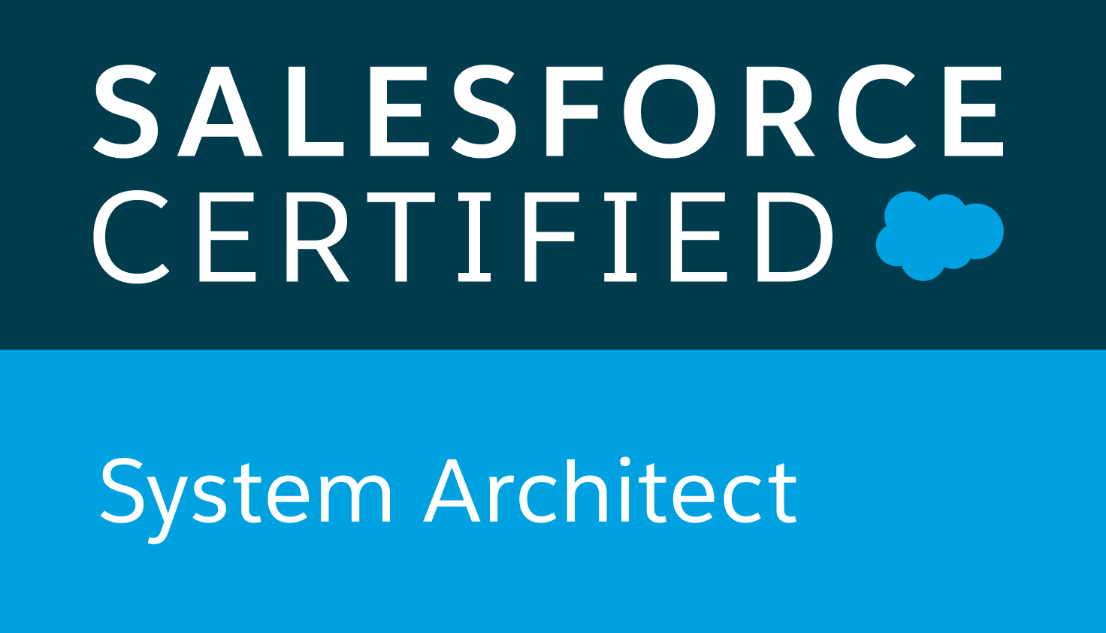
 | 
Work History

Texas Capital Bank, Richardson, TX | Oct 2017 to Present
Technical Architect/Sr. Developer/Release Engineer
- Implemented the flagship purchase nCino – bank operating system on Salesforce platform.
- Designed transformational technical solutions by working directly with customers and business.
- Led the customization effort and coordinated with consulting firm’s engineers and analysts.
- Established a release process with Center of Excellence (COE) for Salesforce ecosystem and managed monthly releases.
- Made product purchase decisions after interacting with vendors.

Slalom Consulting, Dallas, TX | July 2017 to Oct 2017
Principal Consultant

Client: Hilltop Securities, Dallas, TX

- Worked with business experts and users to gather and analyze requirements to build a community portal.
- Designed SFDC data models to accommodate back-office ERP schema.
- Designed and developed several lightning components and APEX classes.
- Managed several sandboxes for different releases and iterations.
- Led and managed the Salesforce release management process.
- Successfully deployed several projects and promoted changes using ANT scripts.
- Established Identity-Provider initiated Single-Sign-On from a legacy application.

Experian, Allen, TX | Jan 2017 to Jun 2017
Consultant - Technical Architect/Sr. Developer
Global Corporate System Sales
- Served as a technical lead for the Customer Relationship Management (CRM) system environment (Salesforce.com) on a day-to-day basis
- Conducted technical design and code reviews
- Worked with the business analyst experts and business users to develop/validate requirements
- Worked on integration with several external applications including CallidusCloud CPQ, Seal, Aria etc.
- Led and managed the Salesforce release management process along with environment planning.

Thomson Reuters, Carrollton, TX | Mar 2016 to Dec 2016
Technical Architect/Sr. Developer
Aumentum Tax (https://tax.thomsonreuters.com/aumentum/)
It is a flagship product of the company that offers powerfully comprehensive and flexible tax billing, collection and management solution that helps government offices to accurately and fairly apply property taxes across their jurisdiction.

Jack Henry & Associates, Allen, TX | Dec 2013 to Feb 2016
Consultant - Application Architect/Sr. Developer

Card Processing Solutions Portal
Financial institutes were users of this portal which provided access to the data of their ATM machines, configurations, transaction history, rules and mapping details.
Bank of America, Plano, TX | Oct 2005 to Nov 2013
(Formerly Countrywide Finance before the merge in June 2007)
Application Architect/Sr. Developer
iOriginate (An extremely large and robust enterprise web-based loan origination system)
It is a primary application used by Bank of America’s Consumer Market Division to originate loans for their customers. It provides a capability to the sales force to originate a loan from remote locations, call centers and nationwide located in more than 5000 banking centers.

- Involved in the overall system architecture and development including performance optimization.
- Worked closely with Analyst team in designing and finding solutions for the implementation of new business requirements.
- Managed very successfully quarterly Integrated and monthly independent releases.
- Coded new functionalities in a timely manner with high quality, and on several occasions with zero defects.
- Led a major project on integration with IBM services into existing mortgage application.

Verizon Communications, Irving, TX | Aug 2002 to Sept 2005
Kaiser Permanente, Los Angeles, CA | Jan 02 to Aug 02
Cedars-Sinai Health Center, Beverly Hills, CA | Aug 01 to Dec 01
SGI (Silicon Graphics), Mountain View, CA | May 00 to July 01

